1. 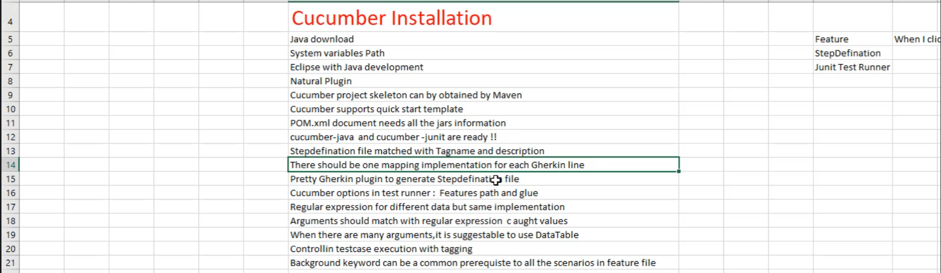
2. 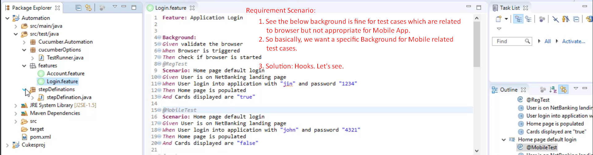
3. Hooks are defined at Step Definition level not at Feature Level.  
   So far we saw how to define background in feature file.
4. **Steps**:
   1. **Step 01**:   
      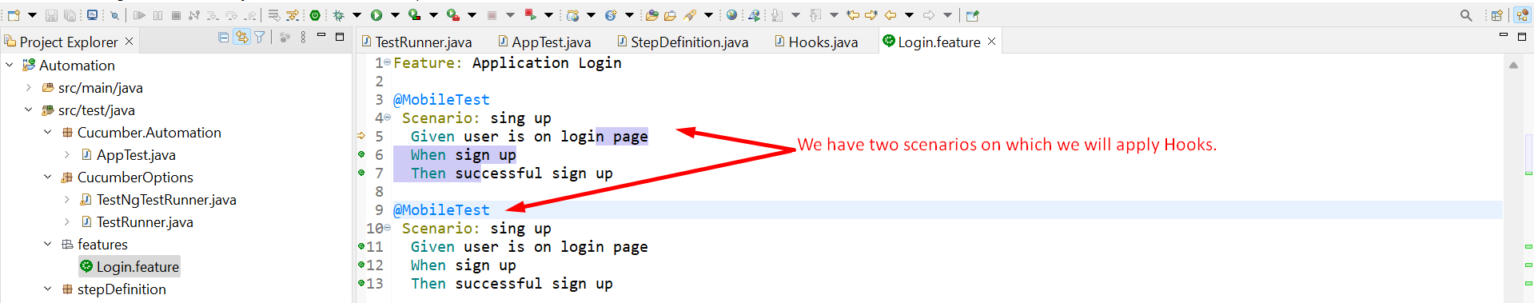
   2. **Step 02**:   
      Graphical user interface, text, application

      Description automatically generated
   3. **Step 03**:  
      Graphical user interface, text, application

      Description automatically generated
   4. **Step 04**:  
      Graphical user interface, text, application

      Description automatically generated
5. **Good Practice**:
   1. If both background and hook are used simultaneously, it may create confusion.